🏋️ Gym Management System
A modern Gym Management System built as a full-stack web application to simplify day-to-day gym administration. The system provides a centralized platform for managing members, trainers, attendance, membership plans, and payment records through a secure authentication system and an intuitive dashboard.
This project was developed for academic and portfolio purposes to demonstrate full-stack web development skills, database management, authentication, and CRUD operations.

📌 Features

🔐 Authentication
- Secure Admin Login
- Session-based authentication
- Protected dashboard access
- Logout functionality

👥 Member Management
- Add new members
- Update member details
- Delete member records
- View all registered members
- Search and filter members

💪 Trainer Management
- Add trainers
- Update trainer information
- Remove trainers
- View trainer details

📅 Attendance Management
- Mark attendance
- View attendance records
- Track member attendance history

📋 Membership Plans
- Create membership plans
- Edit plans
- Delete plans
- View available plans

💳 Payment Management
- Record fee payments
- Track payment history
- View payment status
- Maintain payment records

📊 Dashboard
- Centralized admin panel
- Quick navigation
- Organized management interface
- Easy access to all modules

📱 Responsive Design
- Mobile-friendly layout
- Tablet compatible
- Desktop optimized
- Clean and intuitive UI

🛠️ Technology Stack

Frontend
- HTML5
- CSS3
- JavaScript
- Bootstrap

Backend
- PHP

Database
- MySQL

Hosting
- InfinityFree

📂 Project Structure
Gym-Management-System/
│
├── assets/
│ ├── css/
│ ├── js/
│ └── images/
│
├── admin/
│
├── database/
│
├── includes/
│
├── pages/
│
├── index.php
├── login.php
├── dashboard.php
└── README.md

🚀 Live Demo
Website
https://vyomra.infinityfreeapp.com

Demo Credentials
Username:
admin
Password:
admin123
This is a demonstration account created for portfolio evaluation.

⚙️ Installation

1. Clone Repository
git clone https://github.com/yourusername/Gym-Management-System.git

2. Move Project
Copy the project folder into:
xampp/htdocs/
or
www/
depending on your local server.

3. Import Database
- Open phpMyAdmin
- Create a database
- Import the provided SQL file

4. Configure Database
Update database credentials inside the configuration file.
Example:
$host="localhost";
$user="root";
$password="";
$database="gym";

5. Run Project
Start:
- Apache
- MySQL
Visit:
http://localhost/Gym-Management-System

📸 Screenshots

📸 Screenshots

Home Page:

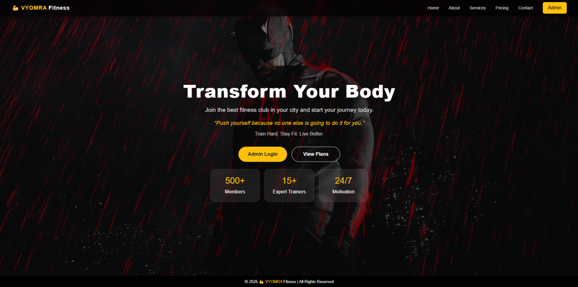

About Page:
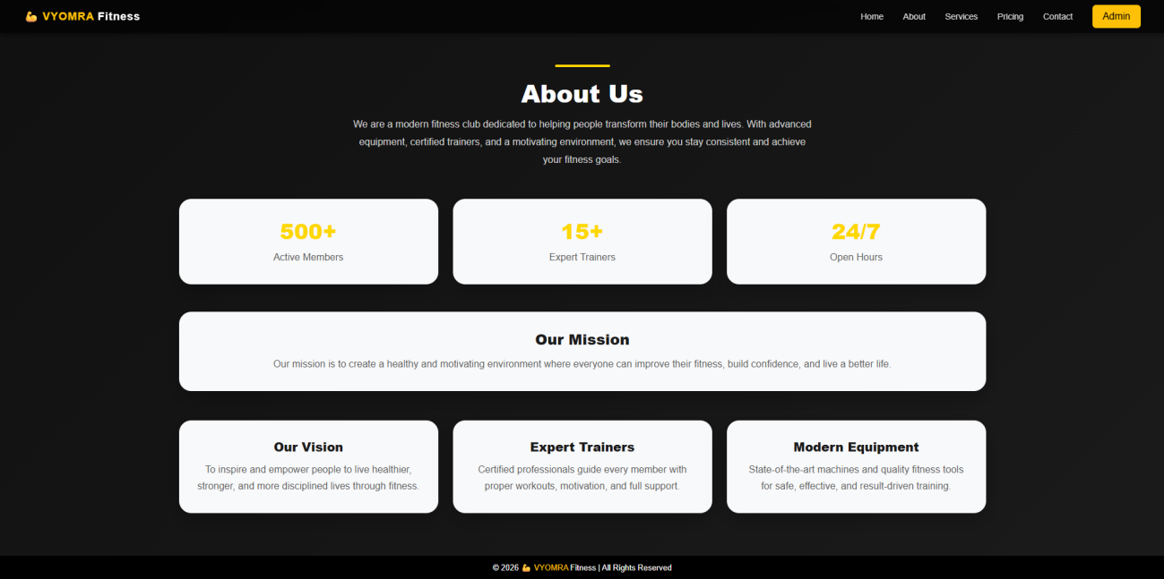

Services Page:
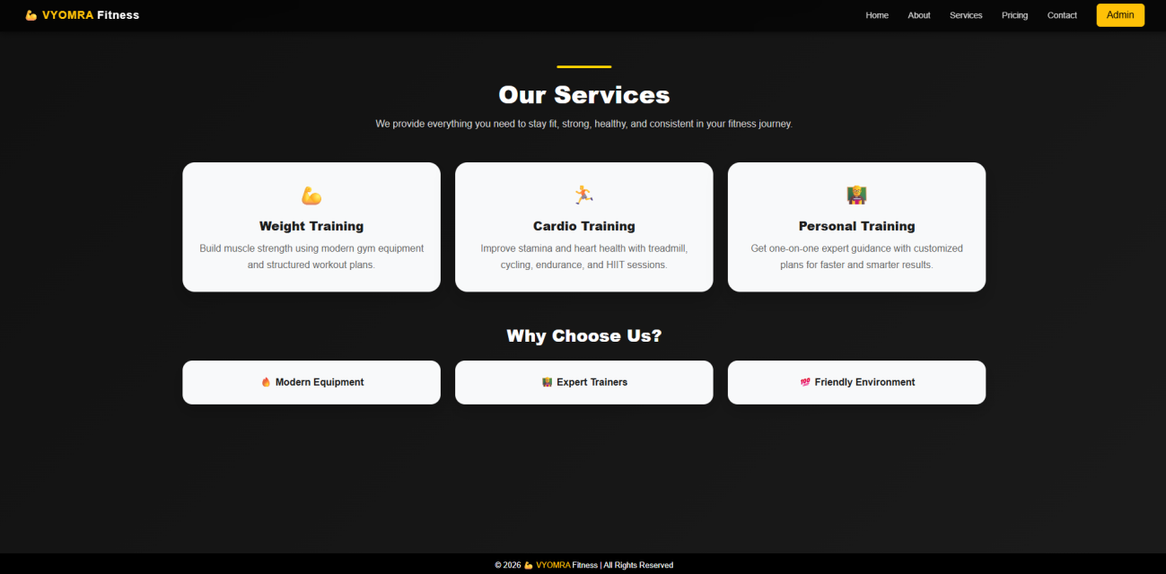

Pricing Page:
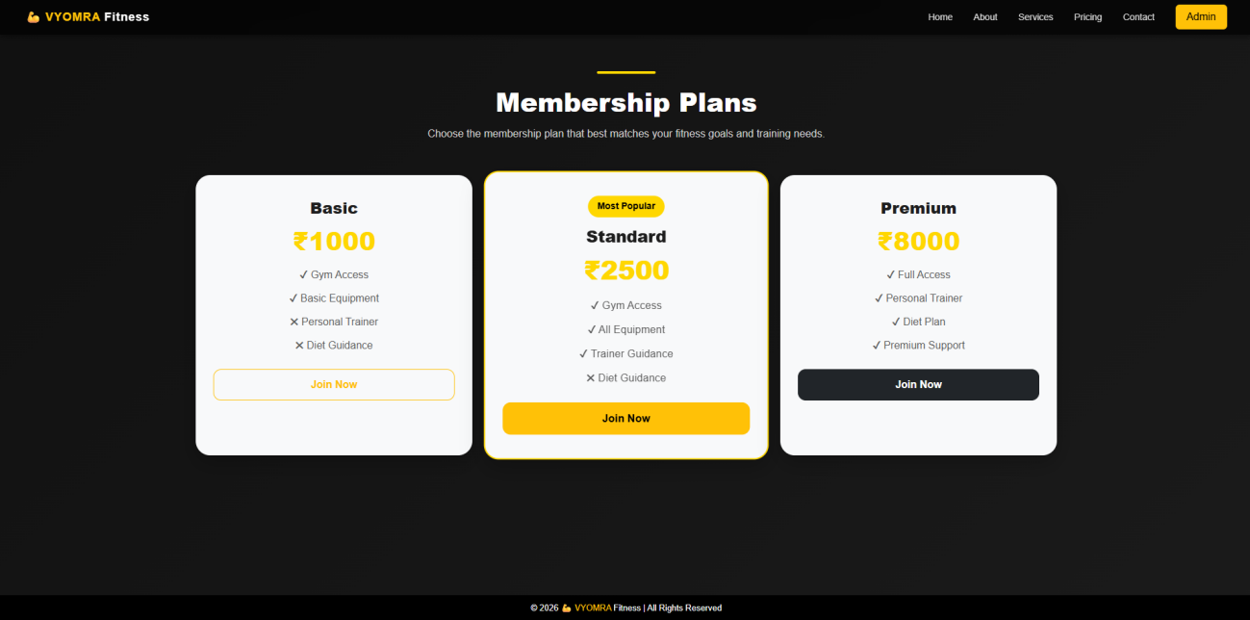

Contact Page:
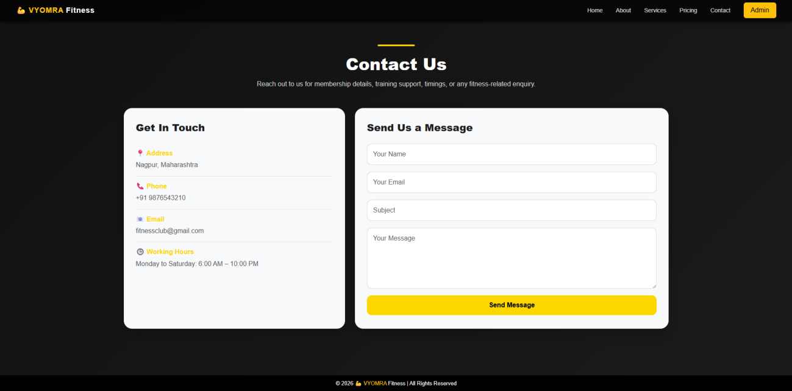

Admin Login Page:
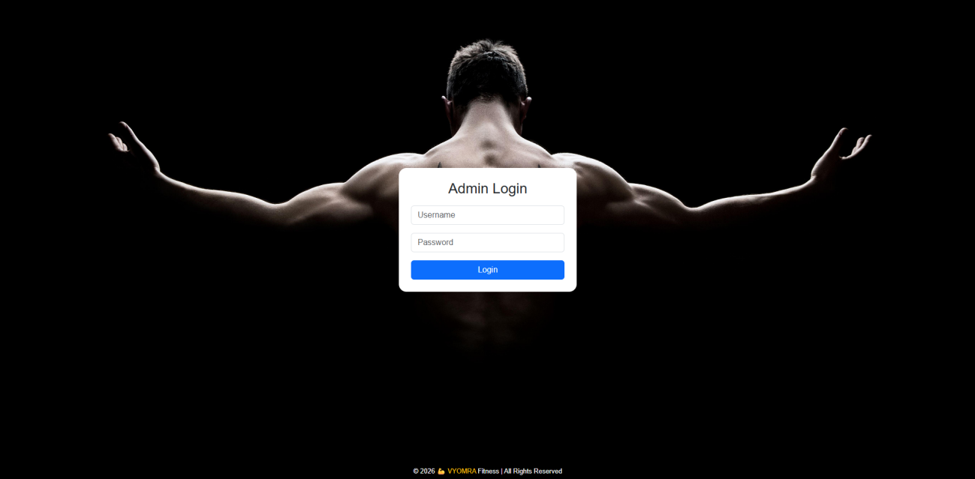

Dashboard:
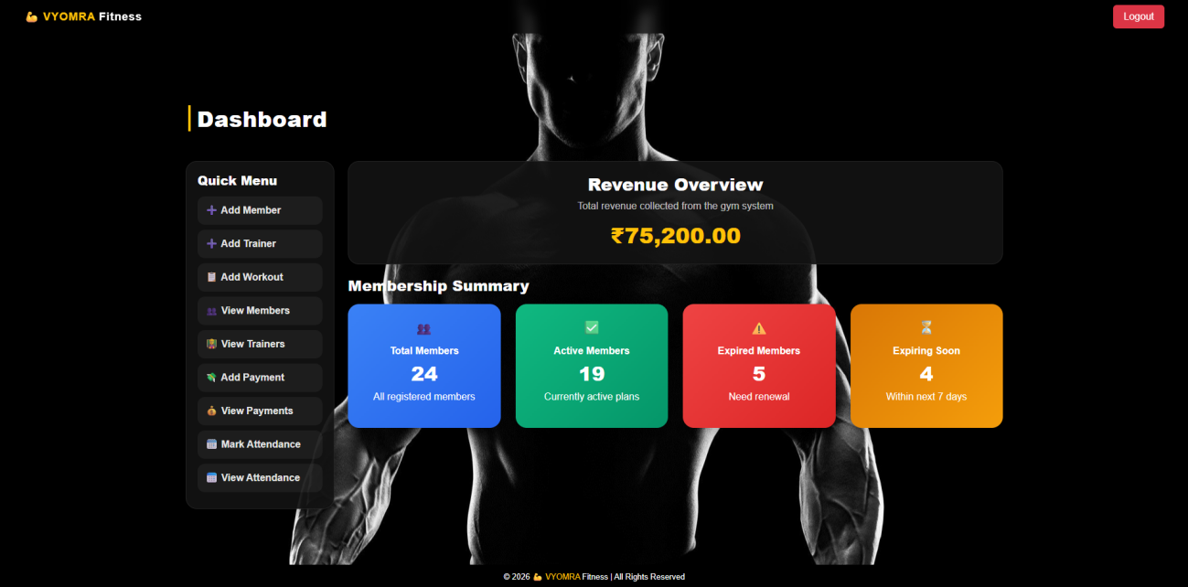

Add Member Form:
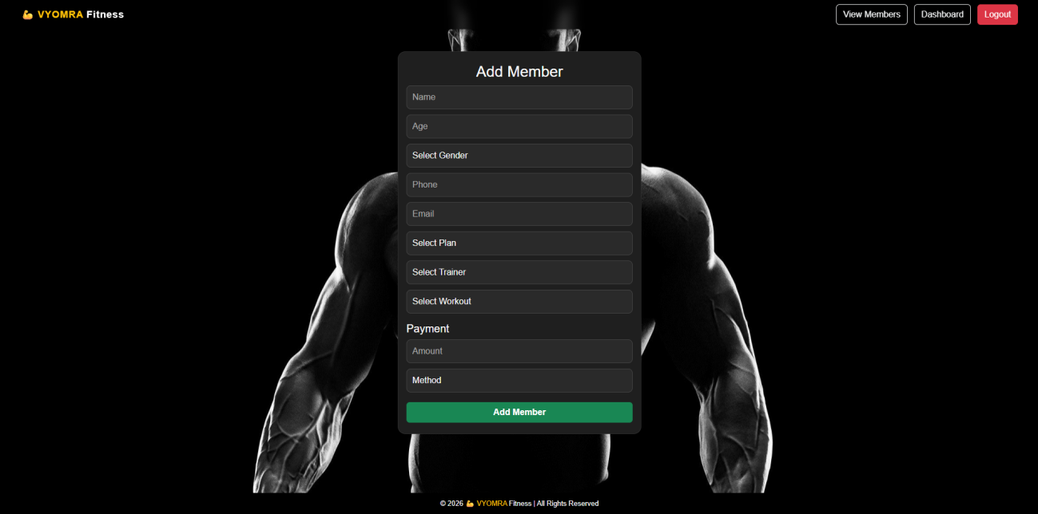

View Members:
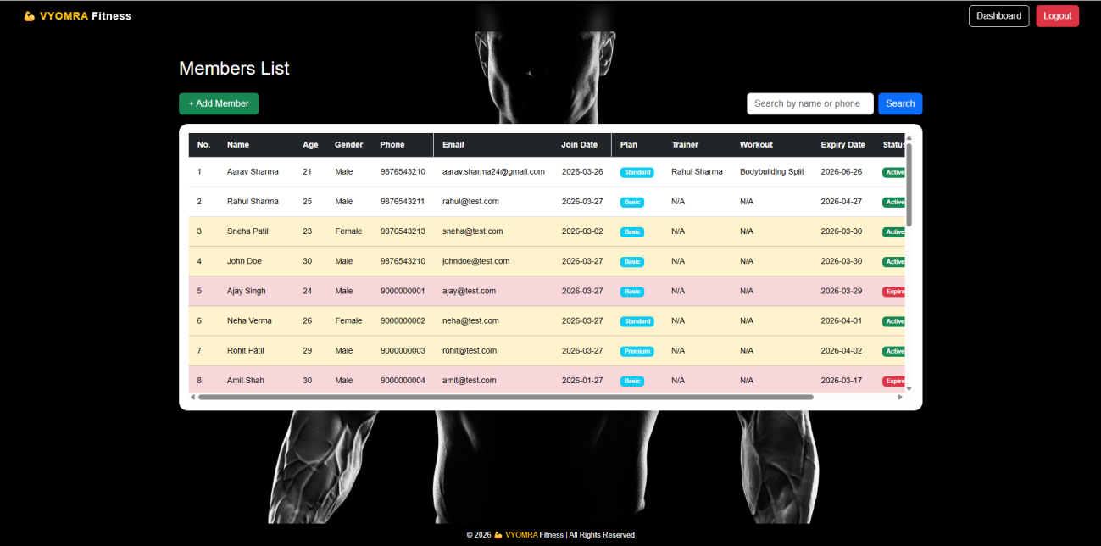

Members List with Actions:
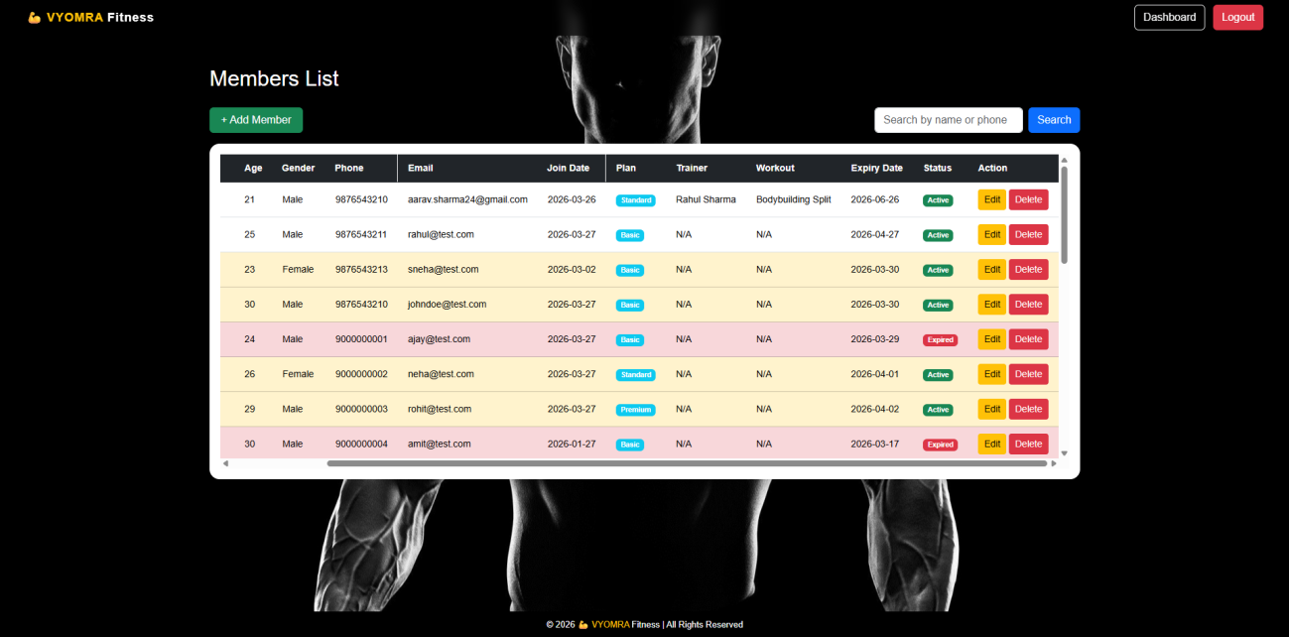

Edit Member:
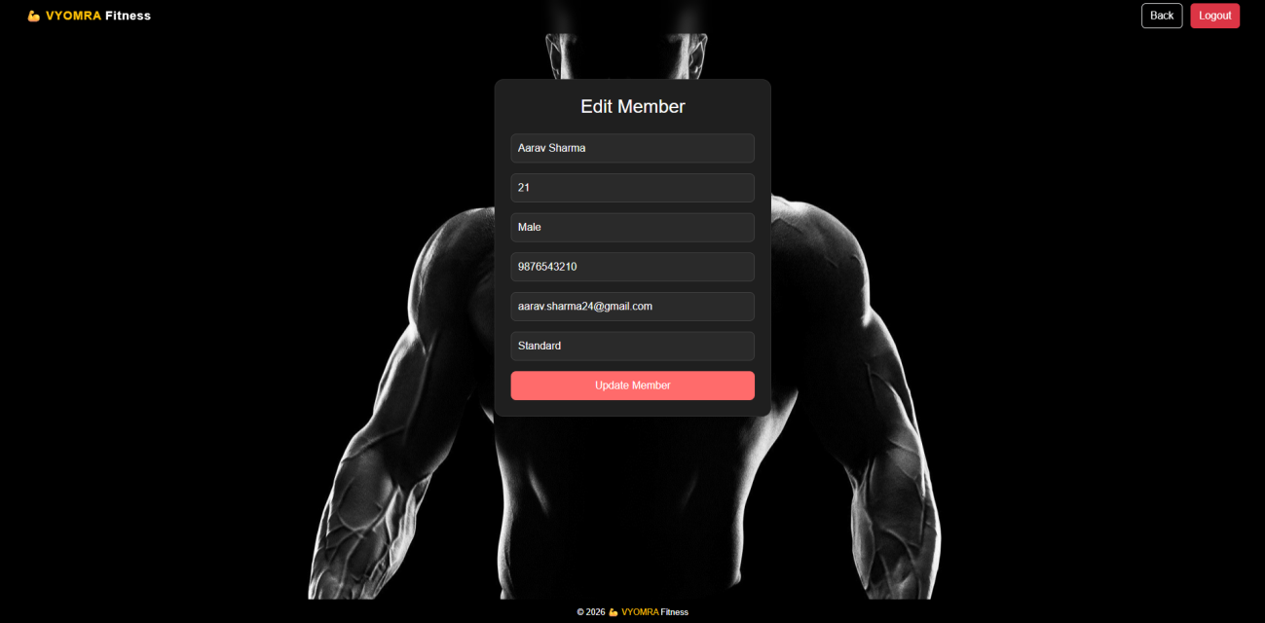

Add Trainer:
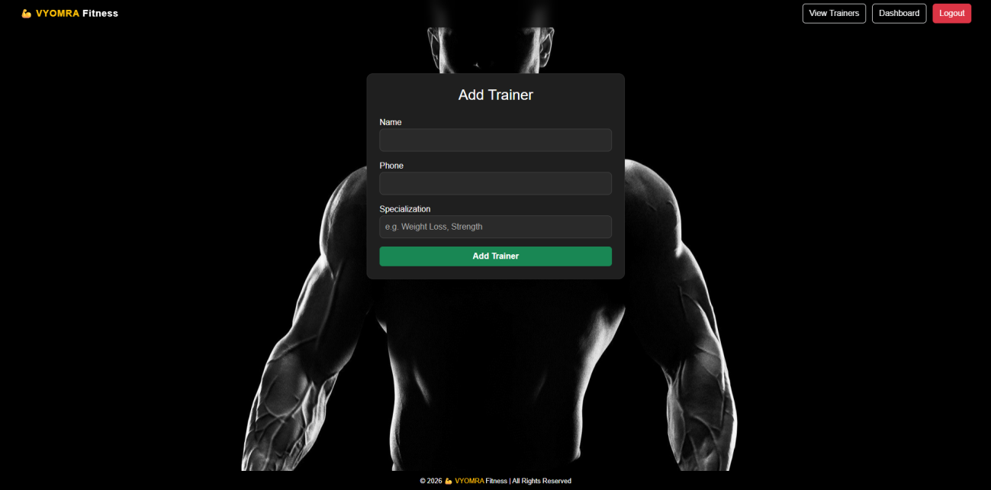

View Trainers:
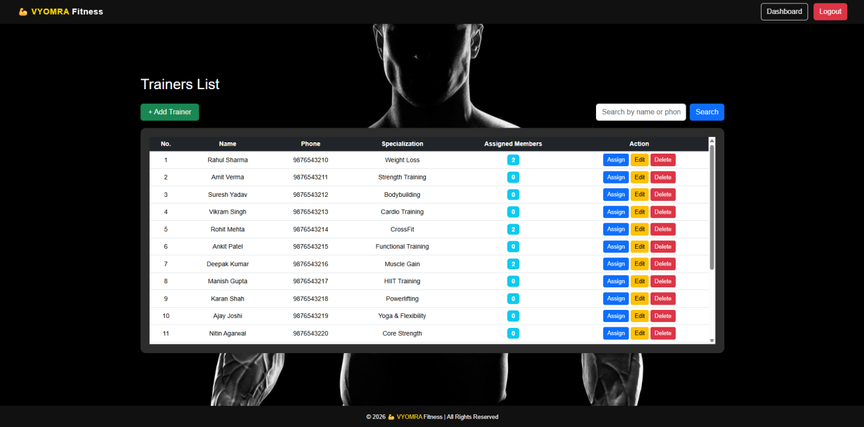

Assign Members to Trainer:
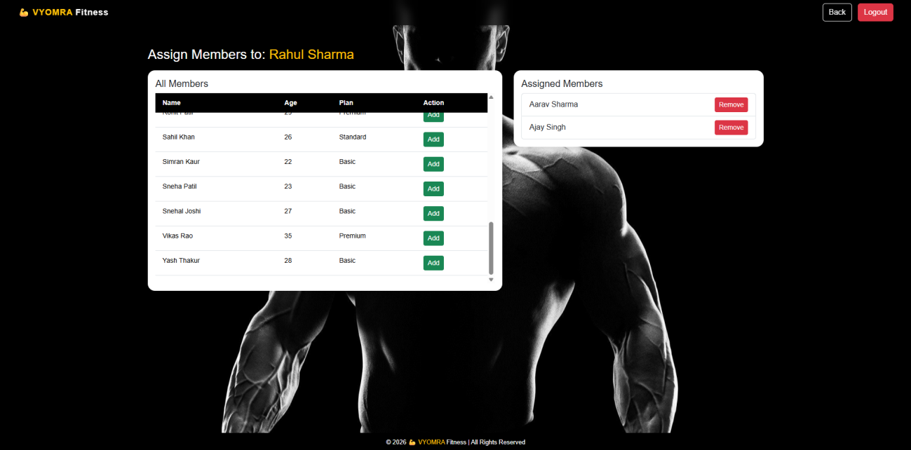

Edit Trainer:
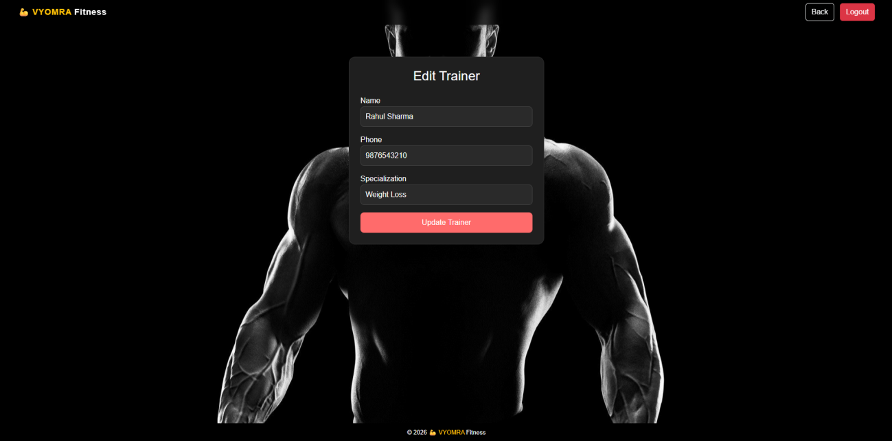

Add Workout Plan:
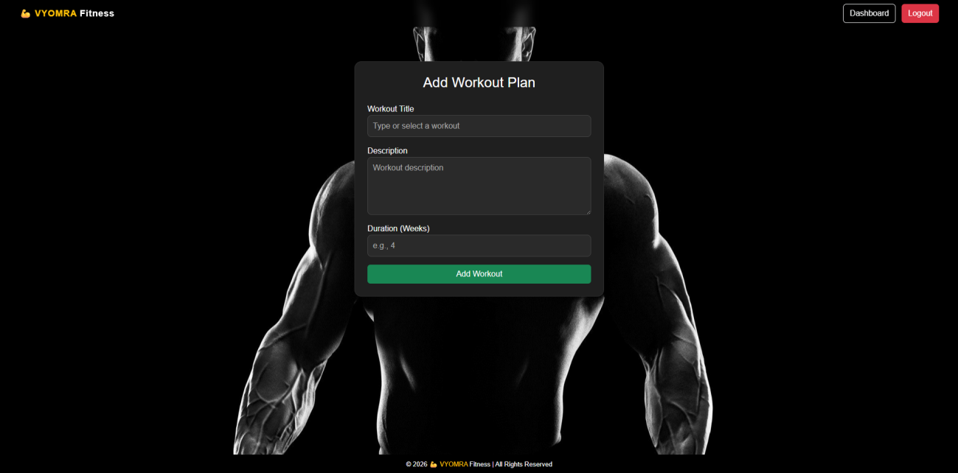

Add Payment:
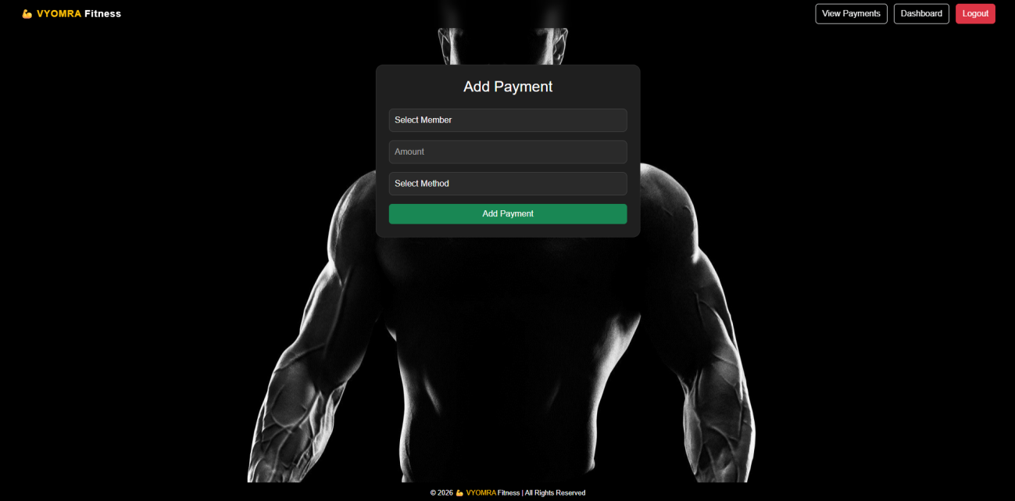

View Payments:
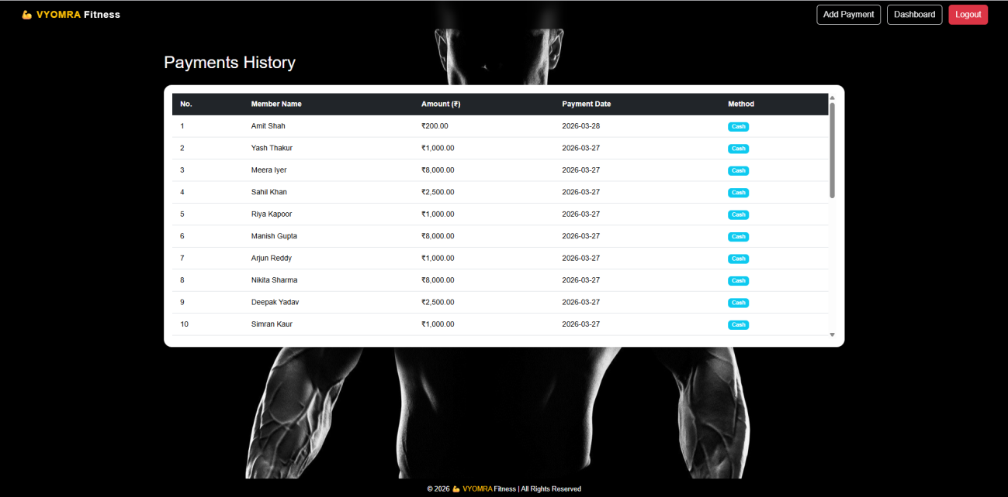

Mark Attendance:
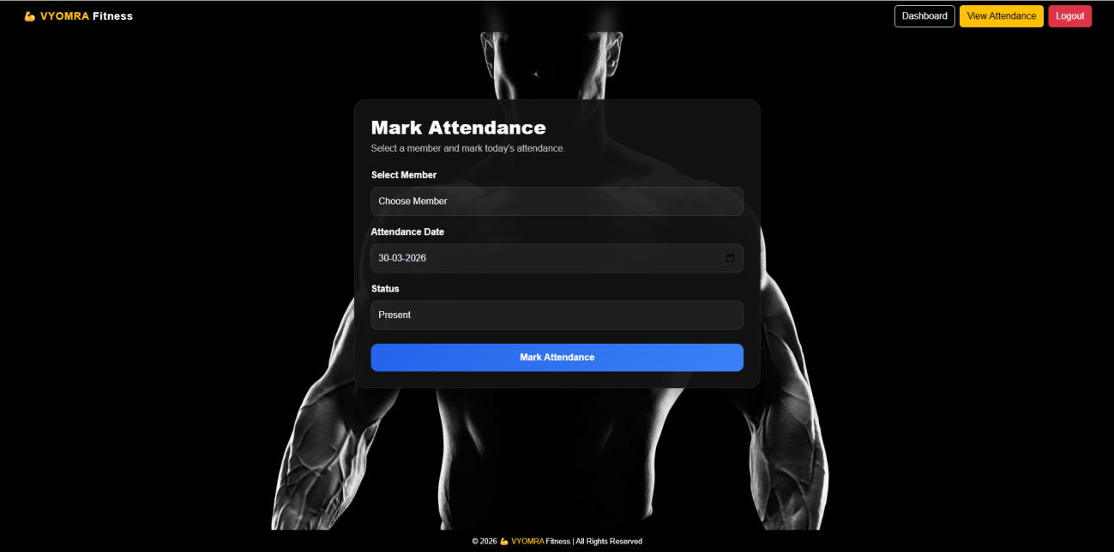

View Attendance Records:
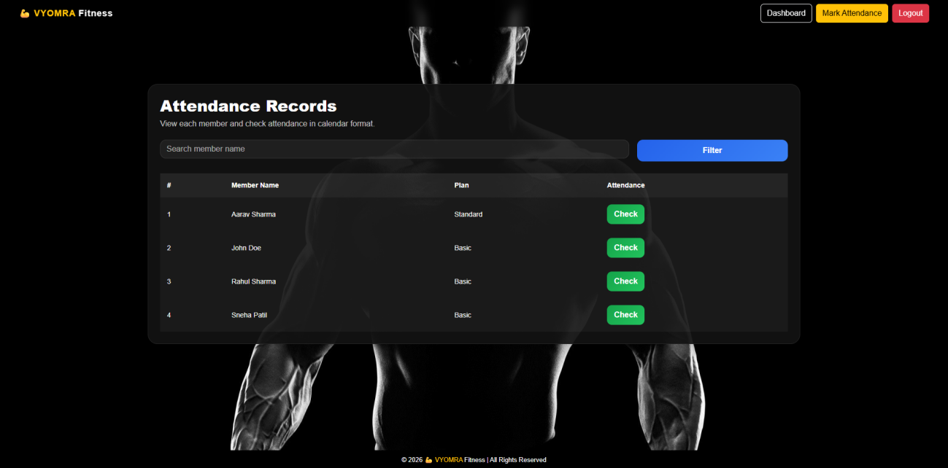
Attendance Calendar:
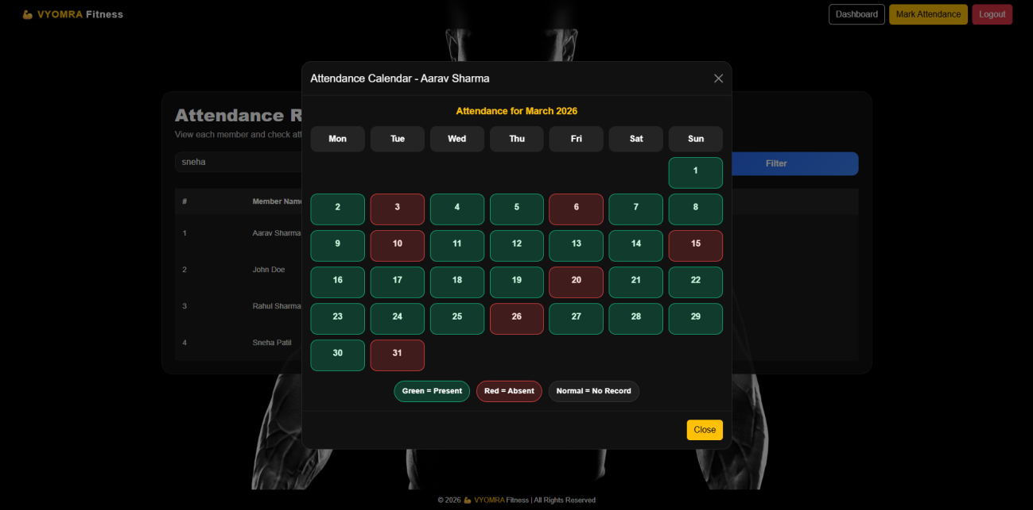

🎯 Learning Outcomes
This project demonstrates:
- Full-stack web development
- Authentication implementation
- CRUD operations
- MySQL database integration
- Responsive web design
- Admin dashboard development
- Session management
- Form validation
- Data management
- Deployment on a live hosting platform

🔮 Future Improvements
- Member login portal
- QR code attendance
- Email notifications
- Online payment gateway
- Trainer schedules
- Workout tracking
- Diet plan management
- Analytics dashboard
- Reports generation
- Multi-admin support

🤖 AI Assistance
AI tools were used during development to assist with debugging, code optimization, problem-solving, and implementation guidance. All features were integrated, tested, and customized as part of the development process.

📄 License
This project is released for educational and portfolio purposes.
Feel free to fork, learn from, and improve the project.

👨‍💻 Author
Developed by Ajit Rathod
Portfolio Project • Full-Stack Web Development

